**RoverNav: Autonomous Rover Navigation System**

Before diving into the technical details, this project implements an intelligent rover navigation system capable of autonomous movement, pathfinding, and sensor-based decision making. The system features automatic recharging, supply drop detection, and return-to-base functionality through a web-based control interface.

**Problem Statement**

Modern autonomous rovers face several critical challenges in unstructured environments:

1. Navigating efficiently without human intervention in varying terrains
2. Managing limited energy resources during extended missions
3. Accurately identifying delivery or sample collection points
4. Returning safely to base after mission completion
5. Maintaining reliable communication and sensor processing in unpredictable conditions[1][2]

**Solution Overview**

RoverNav provides a comprehensive solution that addresses these challenges through:

1. Sensor fusion for intelligent navigation decisions
2. Optimized A* pathfinding for efficient route planning
3. Automatic battery monitoring and recharging functionality
4. Web-based control interface for mission management
5. Supply drop point detection via RFID sensors[1][3][2]

**Technical Architecture**

**Core Components**

The system consists of several integrated modules working together:

**1. Direction Determination Module**

This component processes sensor data to determine optimal movement direction. It implements a sophisticated algorithm that:

* Analyzes inputs from RFID, IR, ultrasonic, and accelerometer sensors
* Calculates drift to adjust navigation course
* Determines whether the rover has reached its destination[1]

The direction determination logic follows this pattern:

if rfid and ir_sensor and ultrasonic_detected and abs(ultrasonic_distance) <= 5:  
 return "Reached"  
elif rfid and not ir_sensor:  
 return "Right" if drift_x > 0 else "Left" if drift_x < 0 else "Forward" if drift_y > 0 else "Backward"  
# Additional conditions for different sensor combinations

**2. Pathfinding Algorithm**

The system implements the A* algorithm for optimal path planning:

* Calculates heuristic using Euclidean distance
* Processes obstacles in the environment
* Supports diagonal movement with appropriate cost adjustments
* Returns an optimal path from start to goal position[3]

**3. Web Interface**

Built with Flask, the web interface provides:

* Real-time status monitoring of rover position, battery, and sensors
* Controls for starting/stopping navigation
* Visualization of current and planned paths
* Session management for rover control[2]

**4. Navigation System**

The autonomous navigation system handles:

* Supply drop detection via RFID sensor
* Battery monitoring with automatic recharging
* Sensor data processing with error handling
* Return-to-base functionality using calculated paths[2]

**Implementation Details**

**Sensor Data Processing**

The rover uses multiple sensors for environmental awareness:

1. **RFID Sensor**: Detects RFID tags at supply drop or collection points
2. **IR Sensor**: Detects obstacles via infrared reflection
3. **Ultrasonic Sensor**: Measures distance to objects and detects obstacles
4. **Accelerometer**: Measures acceleration in x, y, and z axes for drift calculation[1][2]

The system implements robust error handling for sensor data:

# Example of accelerometer data processing with error handling  
try:  
 if isinstance(accelerometer, list):  
 x = accelerometer[^0] if len(accelerometer) > 0 else 0  
 y = accelerometer[^1] if len(accelerometer) > 1 else 0  
 z = accelerometer[^2] if len(accelerometer) > 2 else 0  
 # Additional processing...  
except Exception as e:  
 print(f"Error processing accelerometer data: {str(e)}, using defaults")  
 x, y, z = 0, 0, 0

**A* Pathfinding Implementation**

The A* algorithm implementation includes:

* Prioritized search using a heap queue
* Efficient heuristic calculation
* Support for both orthogonal and diagonal movement
* Comprehensive path reconstruction[3]

def heuristic(a, b):  
 return math.sqrt((b[^0] - a[^0]) ** 2 + (b[^1] - a[^1]) ** 2)

**Autonomous Navigation**

The navigation system follows these steps:

1. Collect and process sensor data
2. Determine optimal direction based on processed data
3. Execute movement commands
4. Check for RFID tags (supply drop points)
5. Monitor battery levels and recharge if necessary
6. Update position data and UI status[2]

**Battery Management**

One of the most critical features is battery management:

if battery_level is not None and battery_level <= 20:  
 need_recharge = True  
 print(f"*** LOW BATTERY DETECTED: {battery_level}% - RECHARGE NEEDED ***")

When low battery is detected, the system:

1. Stops the rover
2. Initiates recharging procedure
3. Monitors charging progress
4. Resumes mission after successful recharge[2]

**Features**

**Key Functionalities**

1. **Autonomous Navigation**
   * Sensor-based decision making
   * Obstacle detection and avoidance
   * Mission completion recognition
2. **Battery Management**
   * Real-time battery monitoring
   * Automatic recharging when needed
   * Mission resumption after charging
3. **Supply Drop Detection**
   * RFID tag recognition for drop points
   * Automatic stopping at drop locations
   * Position recording for future reference
4. **Return-to-Base**
   * A* path calculation to starting position
   * Efficient route planning
   * Battery management during return journey
5. **Web Interface**
   * Real-time status display
   * Control options for autonomous functions
   * Position and sensor data visualization[1][3][4][2]

**Technology Stack**

The project leverages the following technologies:

**Backend**

* Python for core logic and algorithms
* Flask web framework for interface
* Threading for concurrent operations
* Requests library for API communications

**Frontend**

* HTML/CSS for user interface
* JavaScript for dynamic interactions

**Algorithms**

* A* pathfinding for route planning
* Sensor fusion for navigation decisions
* Error handling and recovery mechanisms[1][3][4][2]

**Challenges and Solutions**

**Technical Challenges**

1. **Sensor Data Reliability**
   * **Challenge**: Inconsistent or missing sensor data causing navigation errors
   * **Solution**: Implemented extensive error handling with default values and data normalization
2. **Battery Management**
   * **Challenge**: Preventing mission failure due to battery depletion
   * **Solution**: Proactive battery monitoring with automatic recharging and position memory
3. **Communication Failures**
   * **Challenge**: API timeouts and connection issues during operation
   * **Solution**: Retry mechanisms with exponential backoff and graceful error handling
4. **Navigation Accuracy**
   * **Challenge**: Maintaining precise positioning without GPS
   * **Solution**: Sensor fusion with drift compensation and accelerometer calibration[1][2]

**Setup Instructions**

**Requirements**

* Python 3.7+
* Flask
* Requests library
* python-dotenv

**Installation**

1. Clone the repository
2. Create a virtual environment: python -m venv venv
3. Activate the environment:
   * Windows: venv\Scripts\activate
   * Unix/MacOS: source venv/bin/activate
4. Install dependencies: pip install -r requirements.txt

**Configuration**

1. Create a .env file with API_BASE_URL pointing to the rover API endpoint
2. Ensure all required Python libraries are installed

**Running the Application**

1. Start the Flask server: python app.py
2. Access the web interface at http://localhost:5000
3. Start a session to connect to the rover and Use the interface to control autonomous navigation or manual movements[4][2]

**Screenshots :**

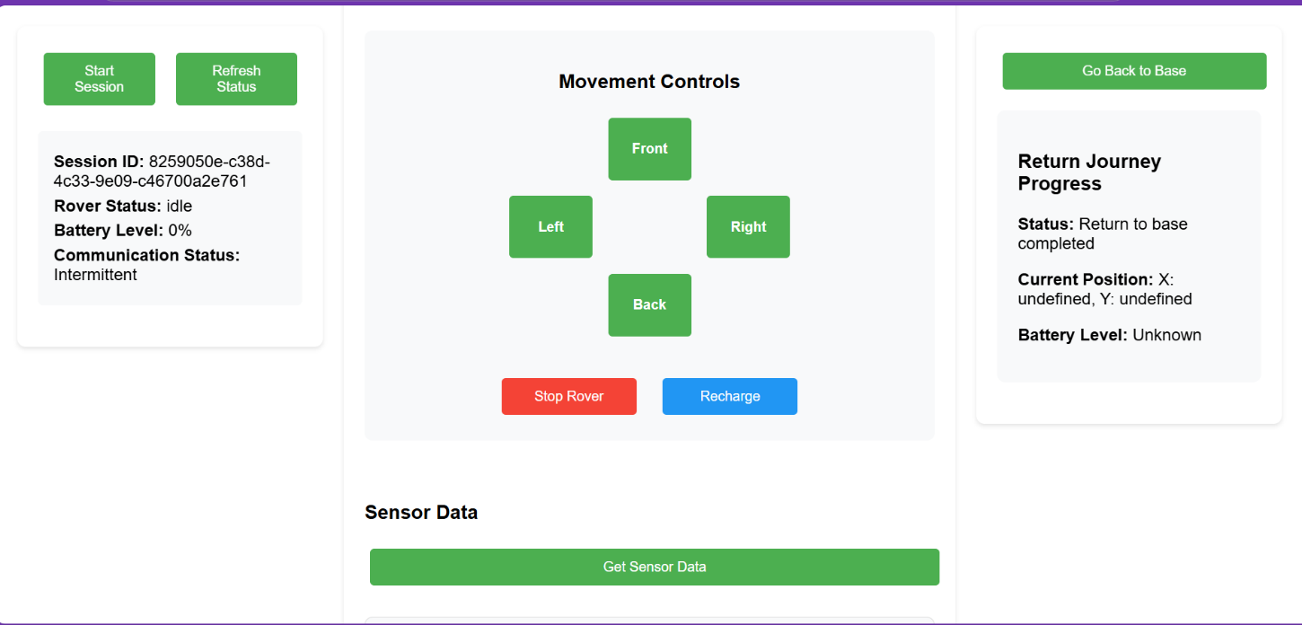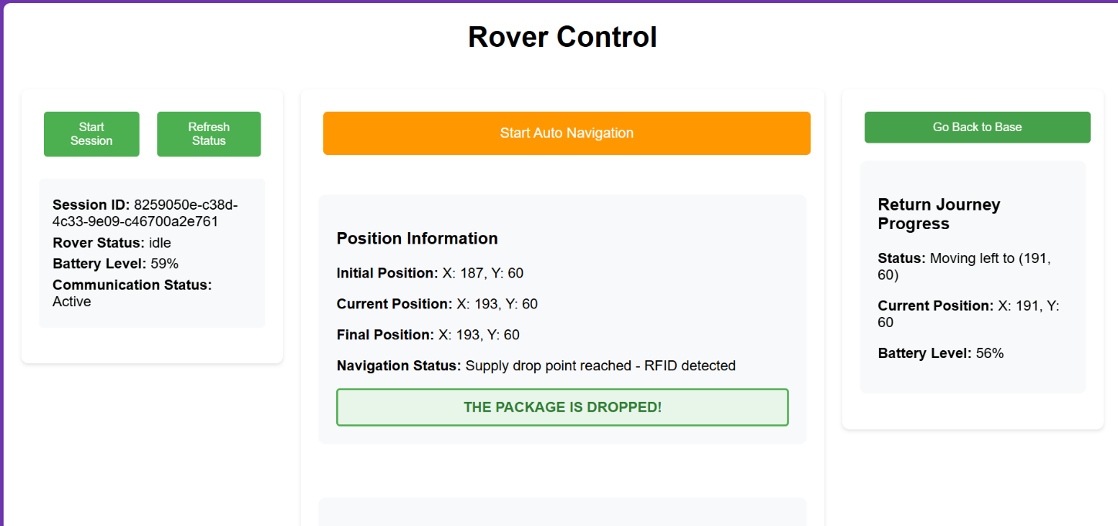

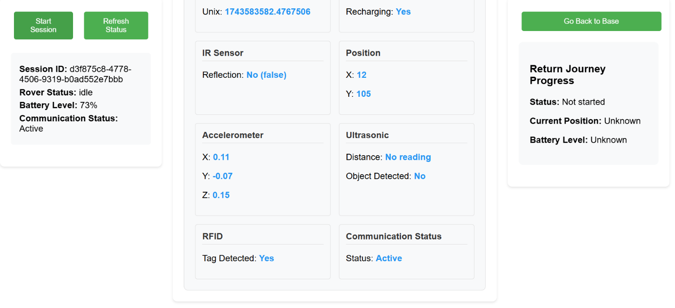

**Conclusion**

RoverNav demonstrates a sophisticated approach to autonomous rover navigation, addressing key challenges in sensor processing, pathfinding, and resource management. The system's modular architecture allows for future enhancements while providing a robust foundation for autonomous operation in various environments.

The integration of sensor fusion, A* pathfinding, and web-based control creates a powerful platform for both educational purposes and practical applications in robotics and autonomous systems.